Lindsey Wilson College’s Doctoral Program in the Spotlight
Doctoral Program in Counselor Education and Supervision of Lindsey Wilson College was in a bright spotlight at the 59th Convention of the Kentucky Counseling Association. This annual convention was held in Louisville, November 9-11, 2016. The theme of this year’s convention was, “Violence and Tragedy Prevention: Trauma Informed Approach, Advocacy and Intervention.”
A dozen of doctoral students, Associate Dean Jackie Montgomery along with 10 faculty members from Counselor Education and Supervision and School of Professional Counseling attended the annual convention of the Kentucky Counseling Association.
Despite the competitive submission process, all doctoral students and faculty members attending the KCA convention made the professional presentations. All the participants in the convention were quite diverse both in gender, ethnic, and racial backgrounds.

Started in August, 2014, the CES program at Lindsey Wilson College is one of the most recent doctoral programs in the state of Kentucky and the United States. This CES award-winning program is preparing doctoral students whose professional service and other scholarly activities are at par excellence.

All our doctoral students: Janet Barnes, Justine Bradley, Hanna Coyot, Leon Ellison, Tamera Fenton, Lori Mc Dunn, Aaron Meriwether, Shameka Sells, Rev. Livinus C. Uba. Darlene Vaughn, and Ebonie Williams made the professional presentations. In additions, ten faculty members from Lindsey Wilson College made the presentations at the annual convention of KCA. These professors included: Drs. Kimberly Brown, Tina M. Glover, Ed Gunberg, Patrick Hardesty, Amy Holsinger, Melinda Mays, Patrice McCarter, Jeff Parsons, Daya Singh Sandhu and Nicole Schnopp-Wyatt.
In addition to three professional presentations with his doctoral students, Dr. Daya Singh Sandhu also conducted two workshops, each for three hours long.
Professional Honors and Awards
Dr. Daya Singh Sandhu, Director of Research and Professor in the Doctoral Program in the Counselor Education and Supervision at Lindsey Wilson College was honored with the Tim Robertson Advocacy Award. Citing an extensive list of advocacy efforts and initiatives through service on several national and international committees and national presidency of Association of Multicultural Counseling and Development, KCA President-Elect Michelle Sircy described Dr. Sandhu as the icon of counseling advocacy before announcing. “Dr. Sandhu, we present this beautiful plaque to you in recognition of your outstanding dedication to the promotion of the counseling profession all over the world and especially for supporting counselors in Kentucky. We thank you for your lifelong work and support of our profession.”
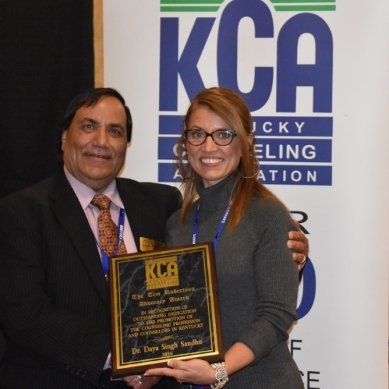
Dr. Daya Singh Sandhu receiving Tim Robertson Advocacy plaque from KCA President Tammy Hurst
Dr. Daya Singh Sandhu Research and Innovations in Counseling Award
In 2016, the winning submission for Dr. Daya Singh Sandhu Research and Innovations in Counseling Award was developed by Dr. Alan Bakes in response to the need for increased collaborative services related to autism spectrum disorders. Dr. Bakes’s project, “Providing Support for Parents of Children with ASD through Collaborative Group Work”, provided a parent support group combined with a research-based parent training and support program.
At the annual convention on November 11, 2016, KCA was proud to award the Dr. Daya Singh Sandhu Research and Innovations in Counseling Award to Dr. Alan Bakes and acknowledged the members of the collaborating team: Dr. Rebecca Pender-Baum, and Dr. Karen Coulter, all from Murray State University.
Dr. Daya Singh Sandhu joined the KCA President Tammy Hurst to present this highly prestigious award established in his name to Dr. Alan Bakes. Dr. Bakes is currently the program coordinator of the Department of Educational Studies, Leadership, and Counseling at Murray State University in Kentucky.

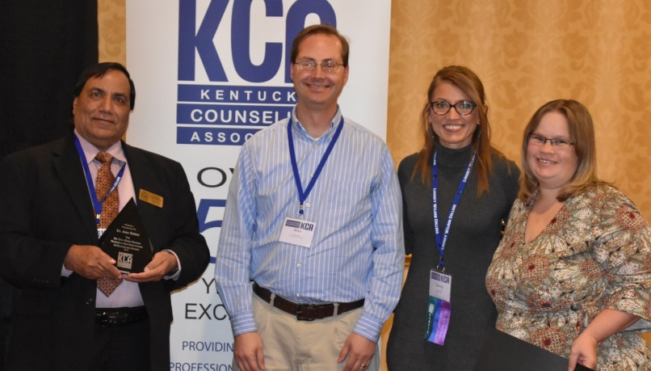
Group Photo from left to right: Dr. Daya Singh Sandhu, Dr. Alan Bakes, KCA President Tammy Hurst, and
Dr. Rebecca Pender-Baum
Special Recognition and Kudos
Lindsey’s doctoral student, Amber Helme, received rave reviews for her panel discussion,
“The counselor’s role in identifying and treating dyslexia” at the KCA Annual Convention in November 2016. It is a matter of great pride and special accolades for Amber that KCA Executive Director Karen Cook has invited her to present on this topic as a pre-conference next year at KCA Annual Convention, 2017. Bravo! We are very proud of you Amber, Congratulations!!

Presenters and Presentations at KCA
Barnes, J., & Fenton, T. (2016, Nov.). The plugged-in family

Bradley, J. (2016, Nov.). Developing empathy for clients, through a trauma informed
approach to avoid counselor burnout

Brown, K. (2016, Nov.). The trials and struggles of women in the workforce: Job
satisfaction in the Appalachian region.

Coyt, H. (2016, Nov). Transitions in aging: Coming to terms with change

Fenton, T. (2016, Nov.). Adlerian play therapy with children with attachment disruptions

Fenton, T., & Parsons, J. (2016, Nov.). Digital storytelling: Empowering vulnerable ‘ ‘
voices

Glover, T. (2016, Nov.). Challenges working with Appalachian clients. Addressing
social justice and advocacy

Glover, T. (2016, Nov.). Exploration of supervision: How to get the most of a didactic
relationship

Hardesty, P., & Cunningham, N. (2016, Nov.). Five essentials for good supervision

Helme, A. (2016, Nov.). The counselor’s role in recognizing and treating problems
associated with dyslexia

Kitchen, K., & Holsinger, A. (2016, Nov.). Blobs and pipe cleaners: Play your way to
emotional literacy

Mays, M., Holsinger, & Schnopp-Wyatt, N. (2016, Nov.). Children in grief: Helping
children through the grieving process

Mays, M., Phelps, L., & Schnopp-Wyatt, N. ( 2016, Nov.). Helping teens who grieve

McCarter, P., Williams, E., Sells, S., Meriwether, A., & Ellison, L. (2016, N.). Wellness
and burnout issues related to African Americans counselor educators and doctoral
students in counselor education

McDunn, L., Meriwether, A., & Sandhu, D.S. (2016, Nov.). Minority issues in alcohol/
substance abuse counseling: What you need to know and do about them

Meriwether, A., Dunn, L., & Sandhu, D.S. (2016, Nov.). A marriage or a mirage: When
dreams become nightmares

Sandhu, D.S. (2016, Nov.). Violence in American schools: Practical guidelines for
counselors (Three hours pre-conference workshop).

Sandhu, D.S. (2016, Nov.). Emotionally at-risk students in schools: What counselors
need to know and do about them (Three hours pre-conference workshop).

Sandhu, D.S., McDunn, L., & Meriwether, A. (2016, Nov.). Culturally responsive
counseling in multicultural schools.

Uba, L.C. Rev. (2016, Nov.). The impact of religion in substance use disorder patients in
recovery

Vaughn, D. (2016, Nov.). Exploring substance use in Appalachia: Multigenerational
conditions, counselors & current interventions

Vessels, J., & Holsinger, A.(2016, Nov.). Play therapy goes to school

Pictures of Some Presenters at the KCA Convention
(November 9-11, 2016)

Here are some pictures of the doctoral students and faculty members from Lindsey Wilson College who attended the 59th Annual Convention of the Kentucky Counseling Association on November 9-11, 2016.
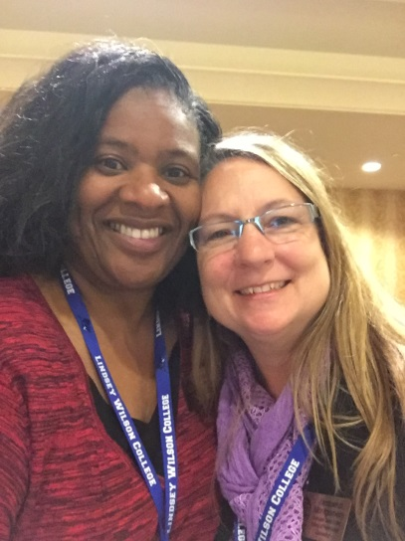
Dr. Kimberly Brown and Associate Dean Jackie Montgomery at the annual convention of the Kentucky Counseling Association

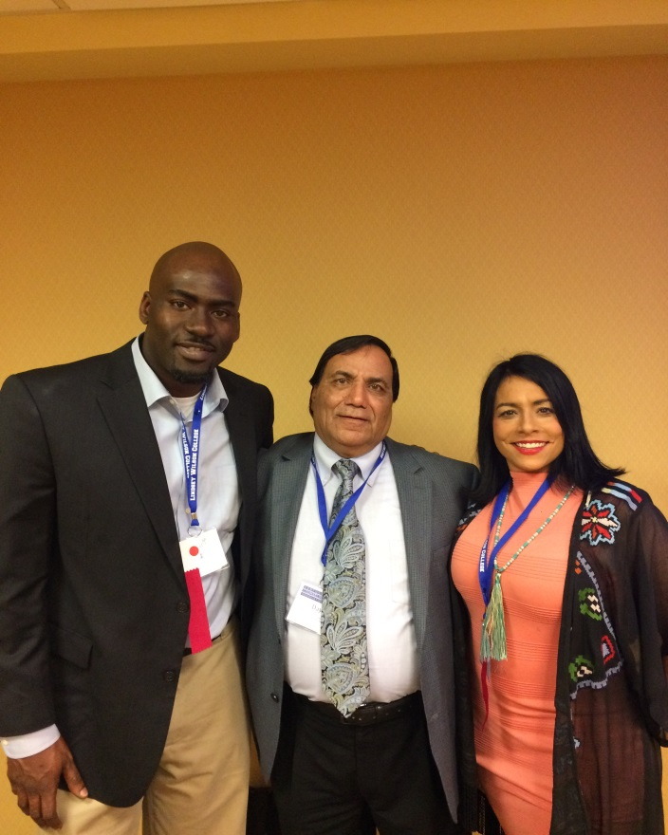
Doctoral Student Aaron Meriwether, Dr. Daya Singh Sandhu, and Doctoral Student Lori McDunn after making three presentations at the annual convention of Kentucky Counseling Association.

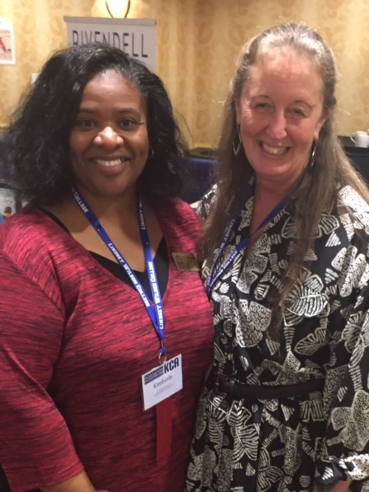
Dr. Kimberly Brown and Darlene Vaughn Doctoral Student at Lindsey Wilson College at the annual convention of the Kentucky Counseling Association
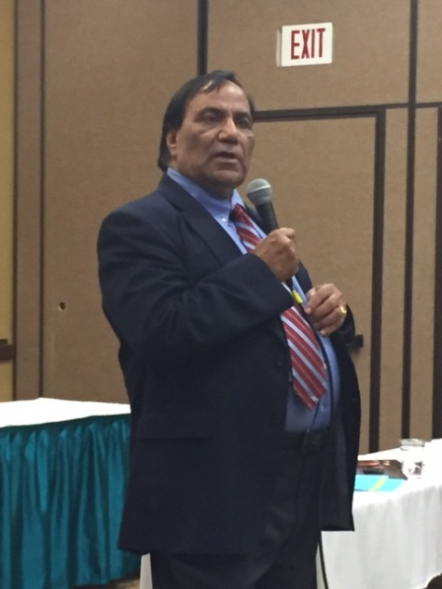
Dr. Daya Singh Sandhu speaking at the annual convention of the Kentucky Counseling Association.

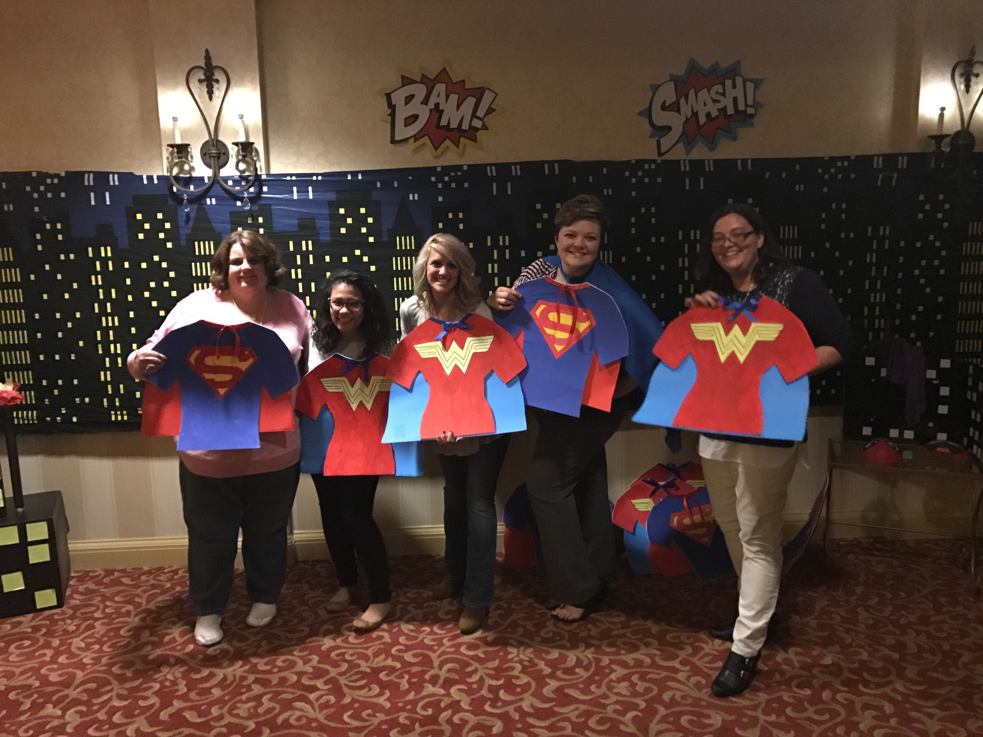

Lindsey’s Doctoral Student Hanna Coyt with other members of KCA

